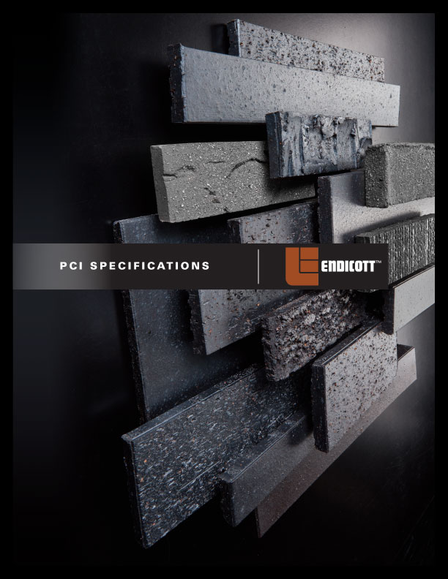
2.10 CLAY PRODUCT UNITS AND ACCESSORIES

Retain this Article if specifying thin brick-faced precast concrete panels which require brick units with tighter dimensional tolerances than ASTM C 1088 or ASTM C 216, Type FBX. TBX or FBX brick units may be too dimensionally variable to fit securely within form liner templates. For economy, brick patterns should minimize cutting of brick. Select thin brick manufacturer and product prior to bid or establish cost allowance. If full-size brick units are required, delete this article and refer to Section 04810 "Unit Masonry Assemblies." The listed characteristics for thin brick units are included in PCI "Standard for Thin Brick". Verify availability of sizes and color.

- Thin Brick Units: Thickness, not less than 1/2 in. (12.7 mm), nor more than 1 in. (25.4 mm) thick, with an overall tolerance of plus 0 in., minus 1/16 in. (+0 mm, -1.59 mm) for any unit dimension 8 in. (203.2 mm) or less and an overall tolerance of plus 0 in., minus 3/32 in. (+0 mm, -2.38 mm) for any unit dimension greater than 8 in. (203.2 mm) measured according to ASTM C 67.

- Face Size: Modular, 21/4 in. (57.15 mm) high by 7 5/8 in. (193.68 mm) long.
- Face Size: Norman, 21/4 in. (57.15 mm) high by 115/8 in. (295.28 mm) long.
- Face Size: Closure Modular, 3 5/8 in. (92.08 mm) high by 7 5/8 in. (193.68 mm) long.
- Face Size: Utility, 3 5/8 in. (92.08 mm) high by 115/8 in. (295.28 mm) long.
- Face Size: <Insert dimension>.

If approving a color range for brick, view 100 square feet (9.3 m²) of loose bricks or a completed building. Edit to suit Project or delete if brick is specified by product name.

- Face Size, Color, and Texture: [Match Architect’s samples] [Match existing color, texture, and face size of adjacent brickwork].

  - <Insert information on existing brick if known>.

Show details of special conditions and shapes on Drawings if required.

- Special Shapes: Include corners, edge corners, and end edge corners.
- Cold Water Absorption at 24 Hours: Maximum 6 percent when tested per ASTM C 67.
- Efflorescence: Tested according to ASTM C 67 and rated "not effloresced."
- Out of Square: Plus or minus 1/16 in. (± 1.59 mm) measured to nearest 1/32 in. (1mm) according to ASTM C 67.
- Warpage: Consistent plane of plus 0 in., minus 1/16 in. (+0 mm, -1.59 mm) measured to nearest 1/32 in. (1mm).
- Variation of Shape from Specified Angle: Plus or minus 1 degree measured to nearest 1 degree using a protractor graduated in ½ degree (30 minute) divisions.
- Tensile Bond Strength: Not less than 150 psi (1.0MPa) when tested per modified ASTM E 488. Epoxy steel plate with welded rod on a single brick face for each test.
- Freezing and Thawing Resistance: No detectable deterioration (spalling, cracking, or chafing) when tested in accordance with ASTM C 666/ASTM C 666M.
- Modulus of Rupture: Not less than 250 psi (1.7MPa) when tested in accordance with ASTM C 67.
- Chemical Resistance: Provide brick that has been tested according to modified ASTM C 650 and rated “not affected.”

Delete subparagraph below if surface-colored brick is not used.

- Surface Coloring: Brick with surface coloring other than flashed or sand-finished brick, shall withstand 50 cycles of freezing and thawing per ASTM C 67 with no observable difference in applied finish when viewed from 20 ft (6 m).

Retain first subparagraph below, deleting inapplicable descriptions if required.

- Back Surface Texture: scored, combed, wire roughened, ribbed, keybacked, or dovetailed.
- Products: Subject to compliance with requirements, products that may be incorporated into the Work include, but are not limited to, the following:

Retain subparagraph above for nonproprietary or subparagraph below for semiproprietary Specification. Refer to Division 01 Section "Materials and Equipment."

- Products: Subject to compliance with requirements, [provide the following] [provide one of the following] [available products that may be incorporated into the work include, but are not limited to, the following]:
  - <Insert in separate subparagraphs, manufacturers’ name and product name or designation.>

Refer to American National Standards Institute (ANSI) A 137.1 for the commonly available sizes and shapes, physical properties, the basis for acceptance, and methods of testing ceramic tile units.

- Glazed and Unglazed Ceramic Tile Units: ANSI A 137.1 (not less than 3/8 in. [10 mm]).

- Body of glazed tile shall have a water absorption of less than 3% using ASTM C 373.
- Manufacturer shall warrant materials as frost-resistant.
- Glazed units shall conform to ASTM C 126.

- Architectural Terra Cotta Units: Comply with requirements of the manufacturer of the selected Architectural Terra Cotta for the application indicated.

Retain paragraph below if mortar setting clay product unit joints before placing precast concrete mixture.

- Sand-Cement Mortar: Portland cement, ASTM C 150, Type I, and clean, natural sand, ASTM C 144. Mix at ratio of 1 part cement to 4 parts sand, by volume, with minimum water required for placement.

Retain paragraph and subparagraphs below if filling thin brick unit joints with pointing grout after precast concrete panel production

- Latex-Portland Cement Pointing Grout: ANSI A118.6 (included in ANSI A108.1) and as follows:

Select one or both types of grout from first two subparagraphs below.

- Dry-grout mixture, factory prepared, of portland cement, graded aggregate, and dry, redispersible, ethylene-vinyl-acetate additive for mixing with water; uniformly colored.
- Commercial portland cement grout, factory prepared, with liquid styrene-butadiene rubber or acrylic-resin latex additive; uniformly colored.
- Colors: [As indicated by manufacturer's designations] [Match Architect’s samples] [As selected by Architect from manufacturer’s full range].
- Tool joints to a slightly concave shape when pointing grout is thumbprint hard.

- Setting Systems

Retain subparagraphs below if thin brick, ceramic tile, or full brick will be laid after casting of panel.

- Thin brick and Ceramic Tile Units: (Dry-Set Mortar: ANSI A118.1 [included in ANSI A108.1]) (Latex-Portland Cement Mortar: ANSI A 118.4 [included in ANSI A108.1])
- Full Brick Units: Install (Galvanized)(Type 304 stainless steel) dovetail slots in precast concrete: not less than 3/16 in. (0.5 mm thick), felt- or fiber-filled slots or cover face opening of slots. Attach brick units with wire anchors, ASTM A 82 or B 227, Grade 30HS not less than 3/16 in. (W2.8) in diameter and hooked on one end and looped through a 7/8 in. (22 mm) wide, 12-gage (2.68 mm) steel sheet bent over the wire with dovetail on opposite end.

